Develop Security Monitoring Dashboard

Overview

A Security Monitoring Dashboard is a centralized visual interface that consolidates security-related information across projects. It provides a single point of visibility into alerts, vulnerabilities, and security trends, allowing teams to assess their security posture, identify risks, and prioritize remediation activities effectively.

A Security Monitoring Dashboard is critical for maintaining a strong security posture due to the following reasons:

- Visibility: Offers real-time insight into the overall security health of applications.
- Trend Analysis: Enables tracking of security progress over time (e.g., reduction or increase in vulnerabilities).
- Prioritization: Highlights issues by severity, ensuring that critical risks are addressed first.
- Accountability & Reporting: Provides reliable data for daily stand-ups, management reports, and audit requirements.
- Proactive Security: Facilitates a shift from reactive issue fixing to proactive vulnerability management and prevention.

Prerequisites

- A GitHub repository with security alerts enabled (from previous SAST/SCA setups).
- A GitHub Personal Access Token (PAT) with the repo and security_events permissions.
- Basic familiarity with the command line and JSON data.

Step 1: Create a GitHub Personal Access Token (PAT)

To create a secure key that allows our script to read security alerts from our repository via the GitHub API.

- Click your profile picture in the top-right corner of GitHub and select Settings.

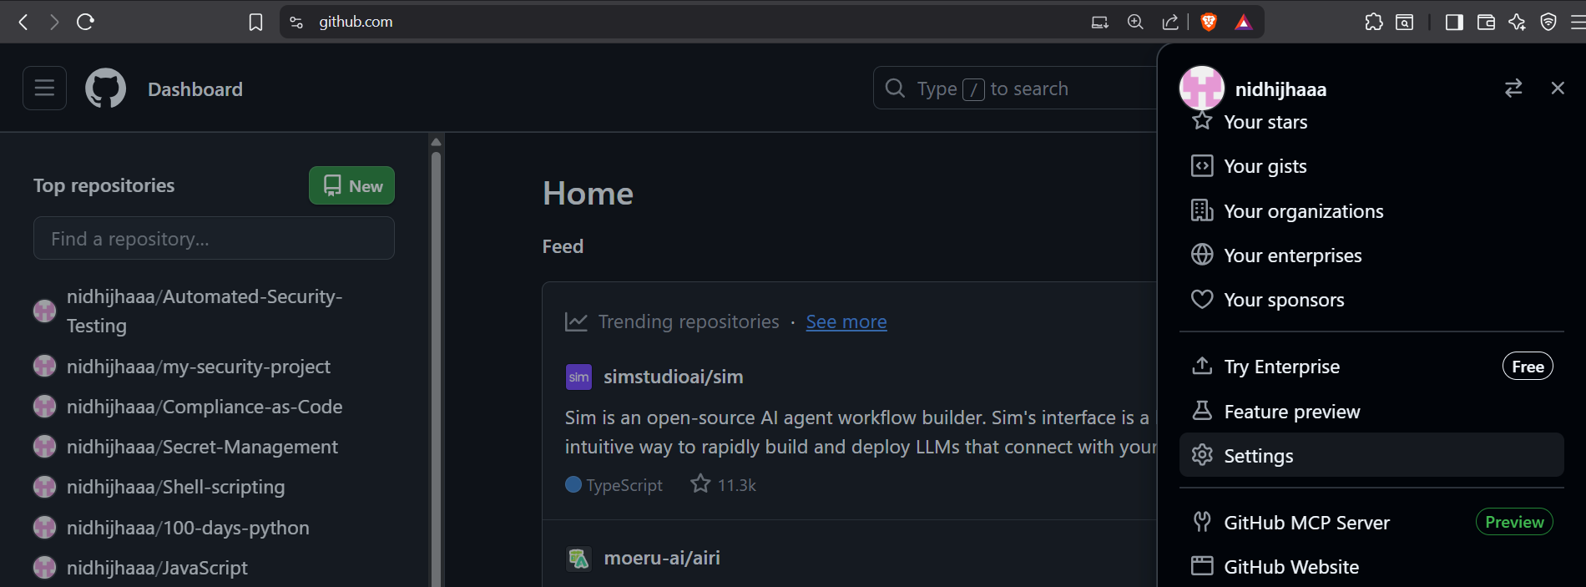

- Scroll down the left sidebar to the very bottom and click Developer settings.

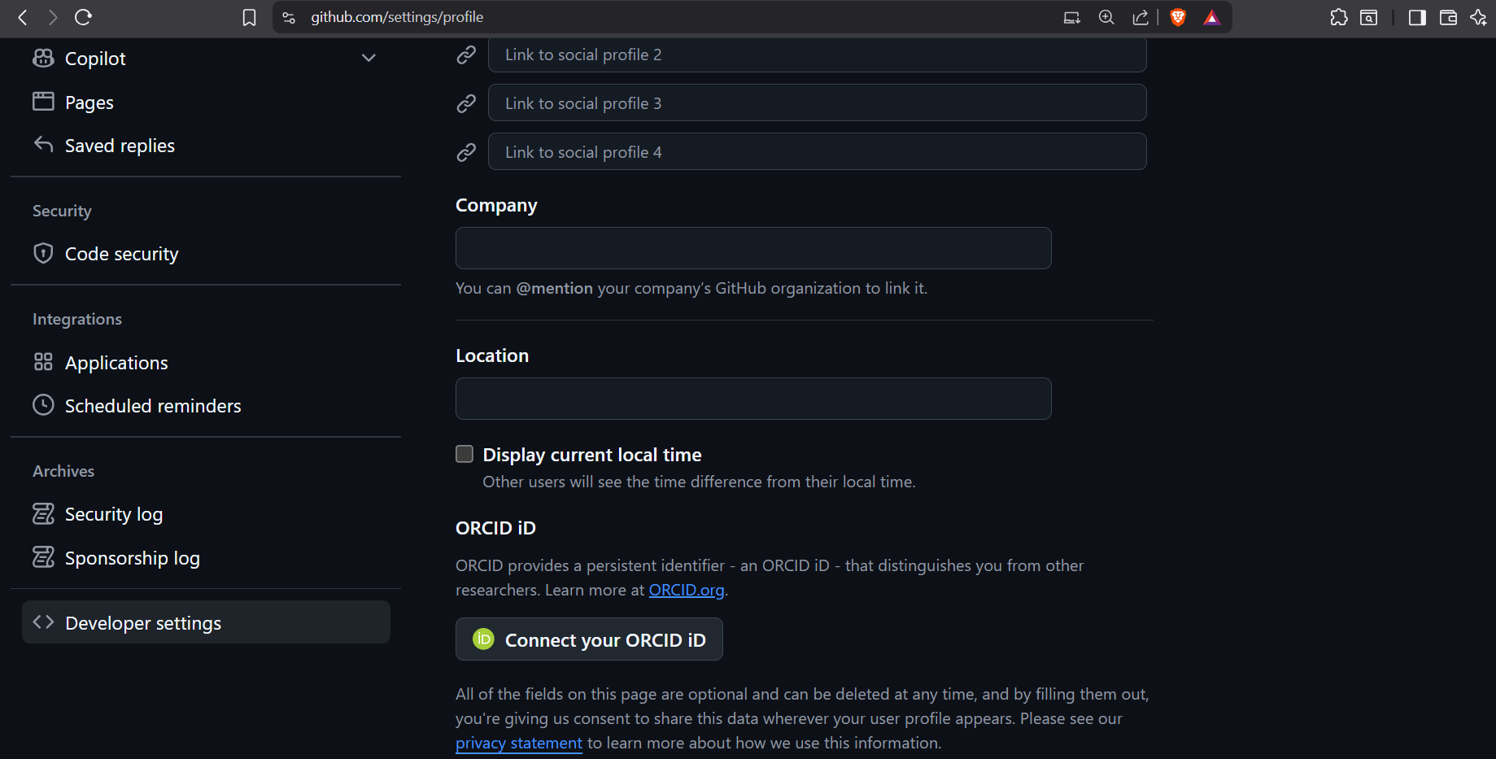

- Create a New Token:
  - Click on Personal access tokens > Tokens (classic).
  - Click the Generate new token dropdown and select Generate new token (classic).

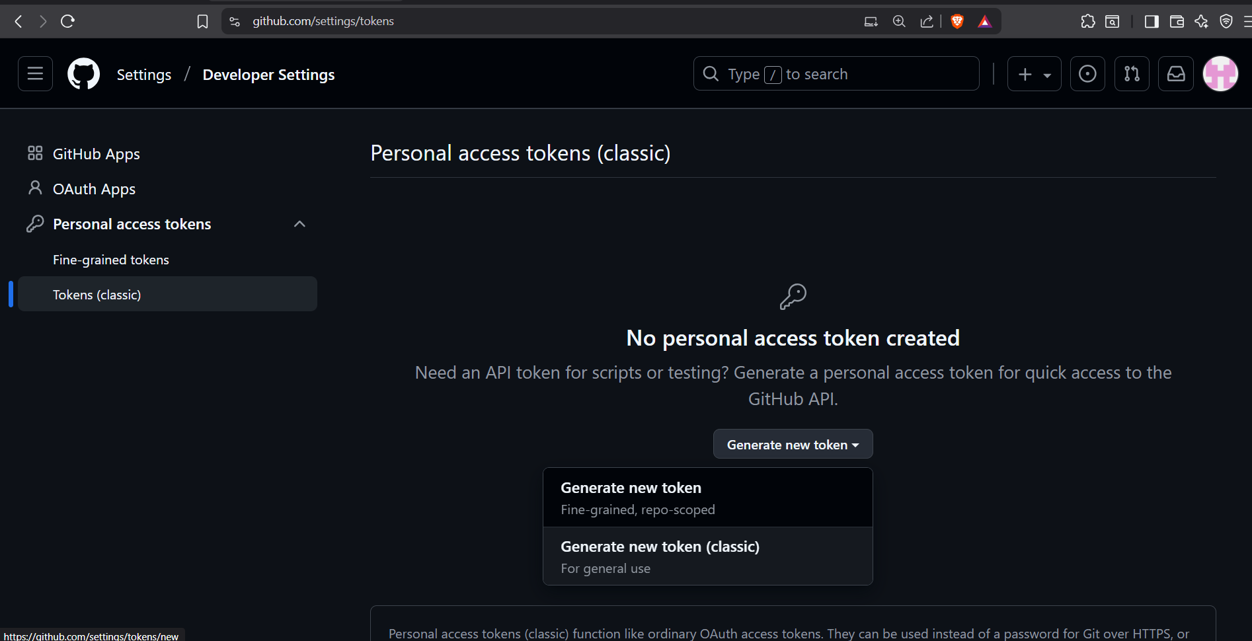

- Enter your password for confirming access.

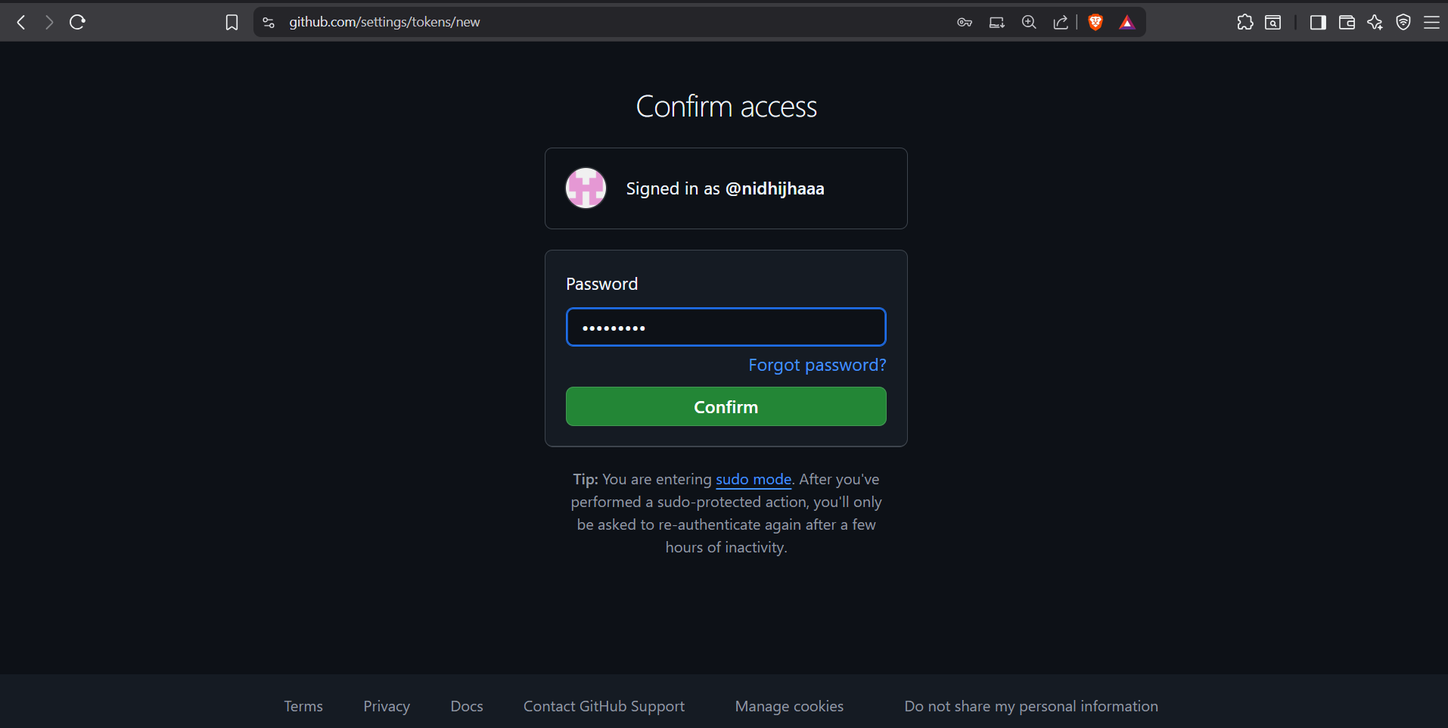

Configure the Token:
- Note: Security Dashboard Script
- Expiration: Set a reasonable expiration (e.g., 30 days). You can regenerate it later.
- Select scopes: Check Full control of private repositories.

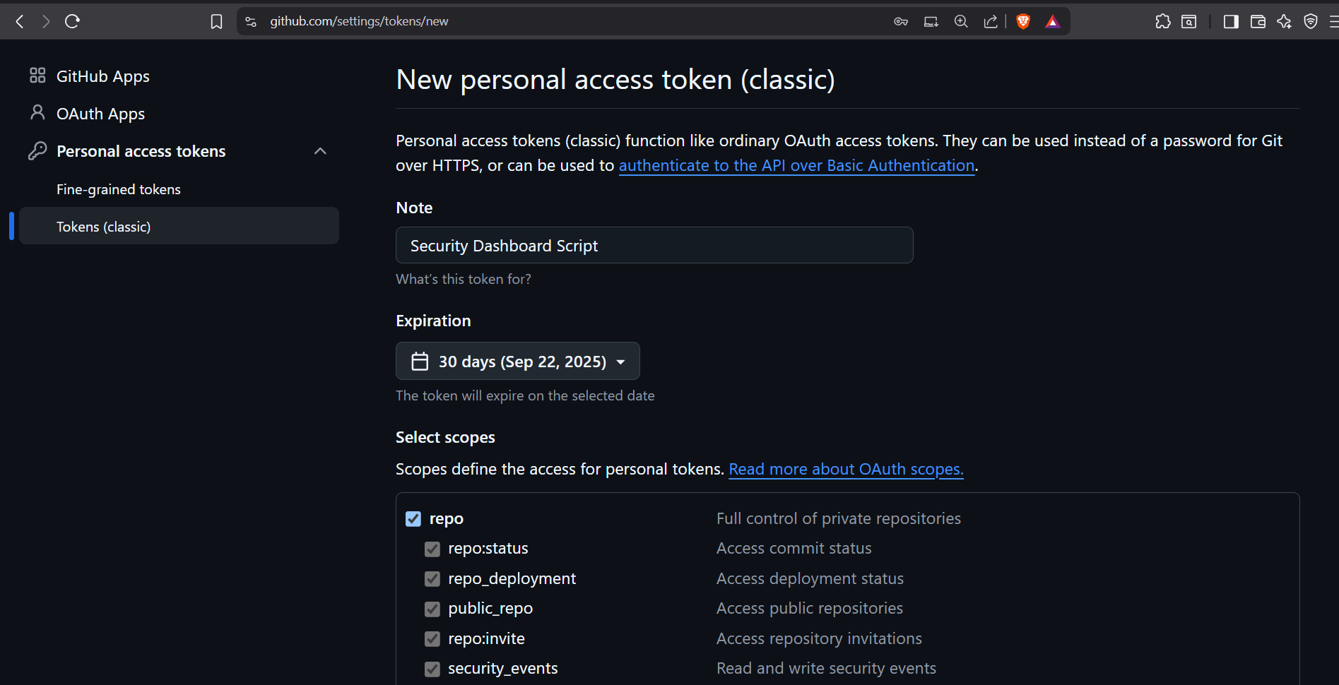

- Check read:audit_log and read:enterprise

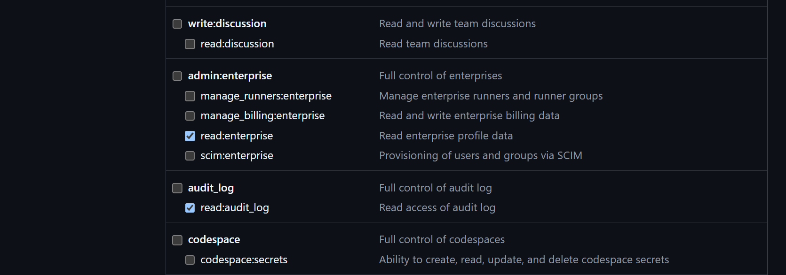

- Click Generate token at the bottom.
- CRITICAL: Copy the token immediately and save it in a secure place. You will not be able to see it again. This is your password.

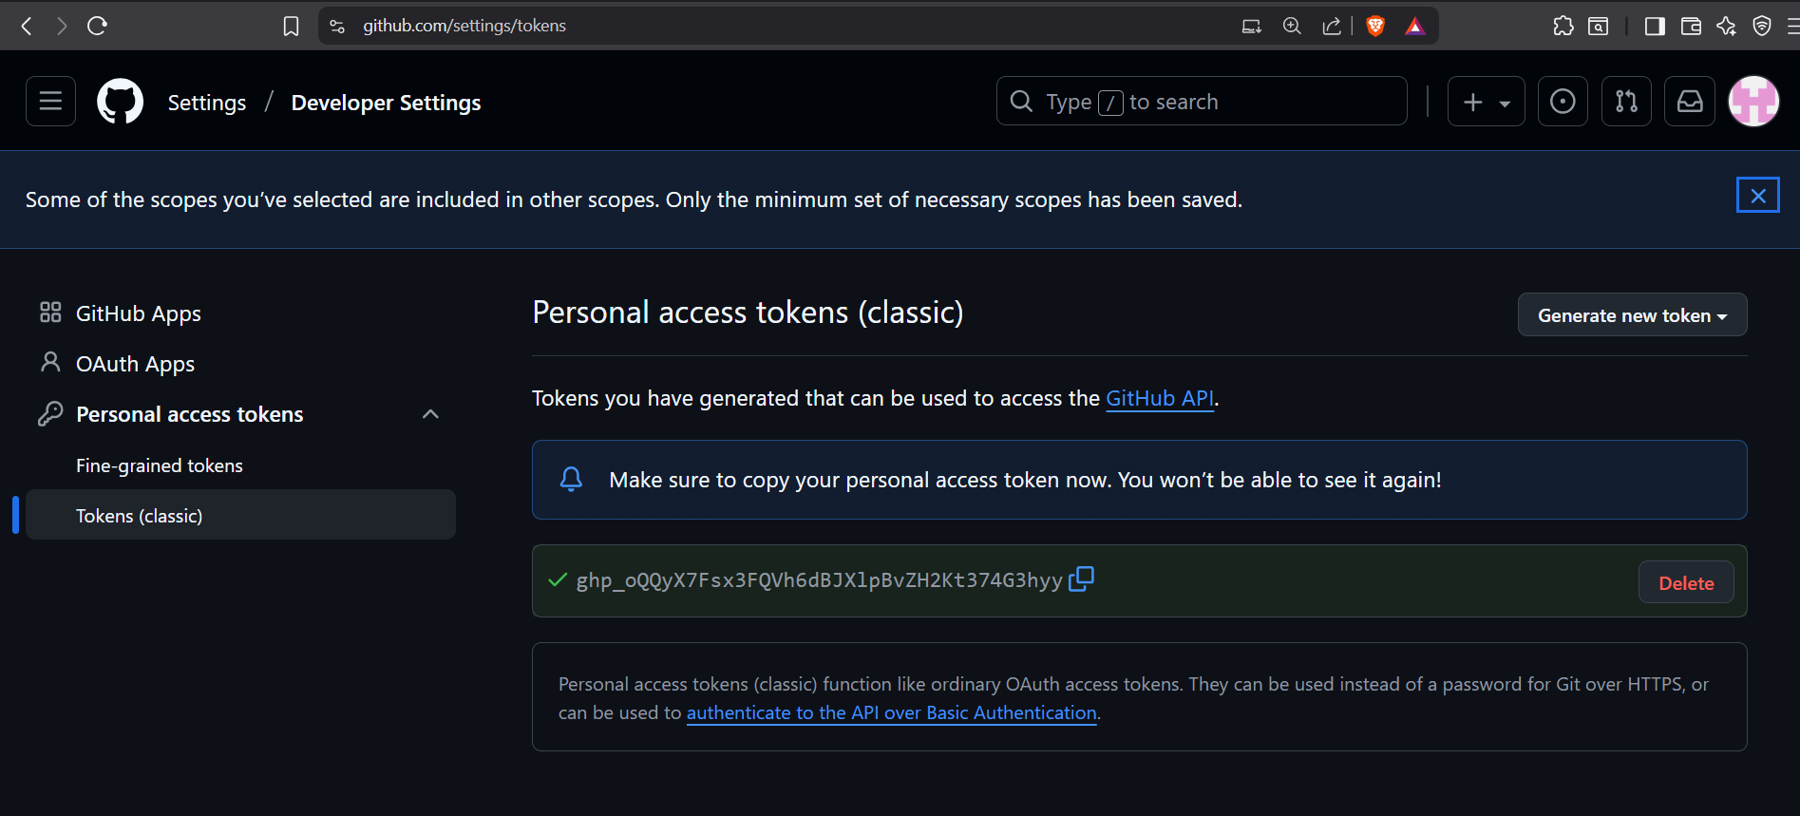

Step 2: Store the PAT as a GitHub Secret

To securely store the PAT in your repository so our workflow can use it without exposing it.

- Click on “New”.

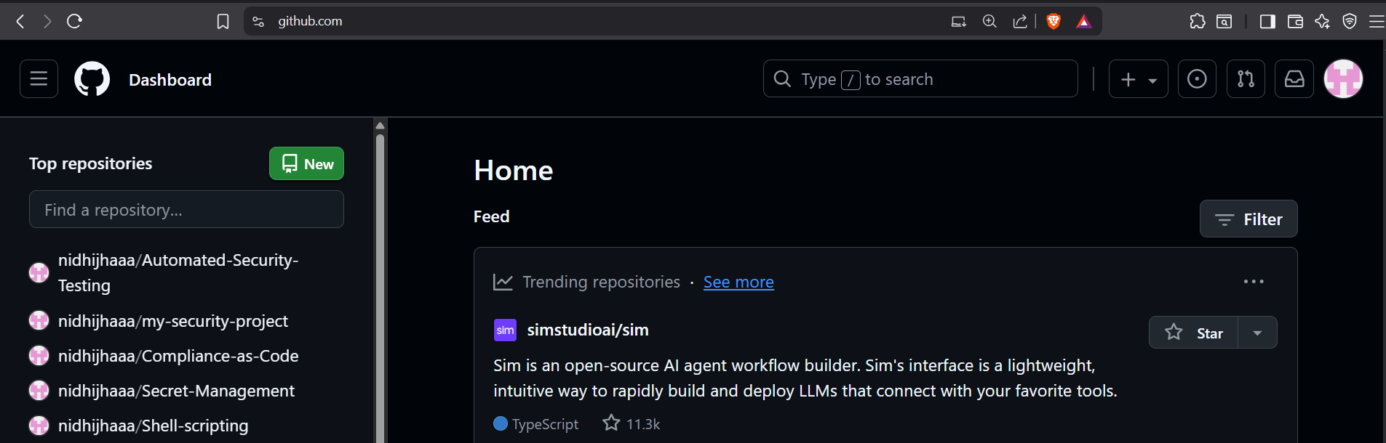

- Enter repository name
- Choose visibility “Public”
- Make sure to add Readme file.
- Click “Create Repository”.

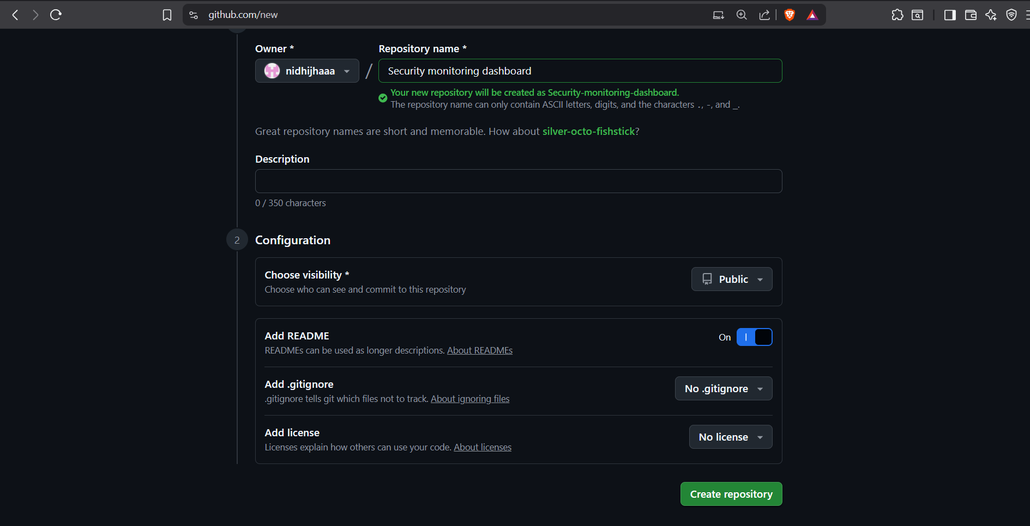

- Go to your repository's Settings

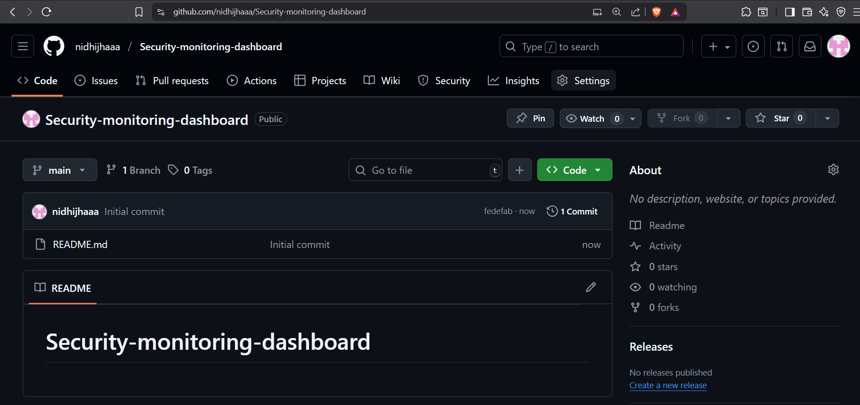

- Secrets and variables Actions

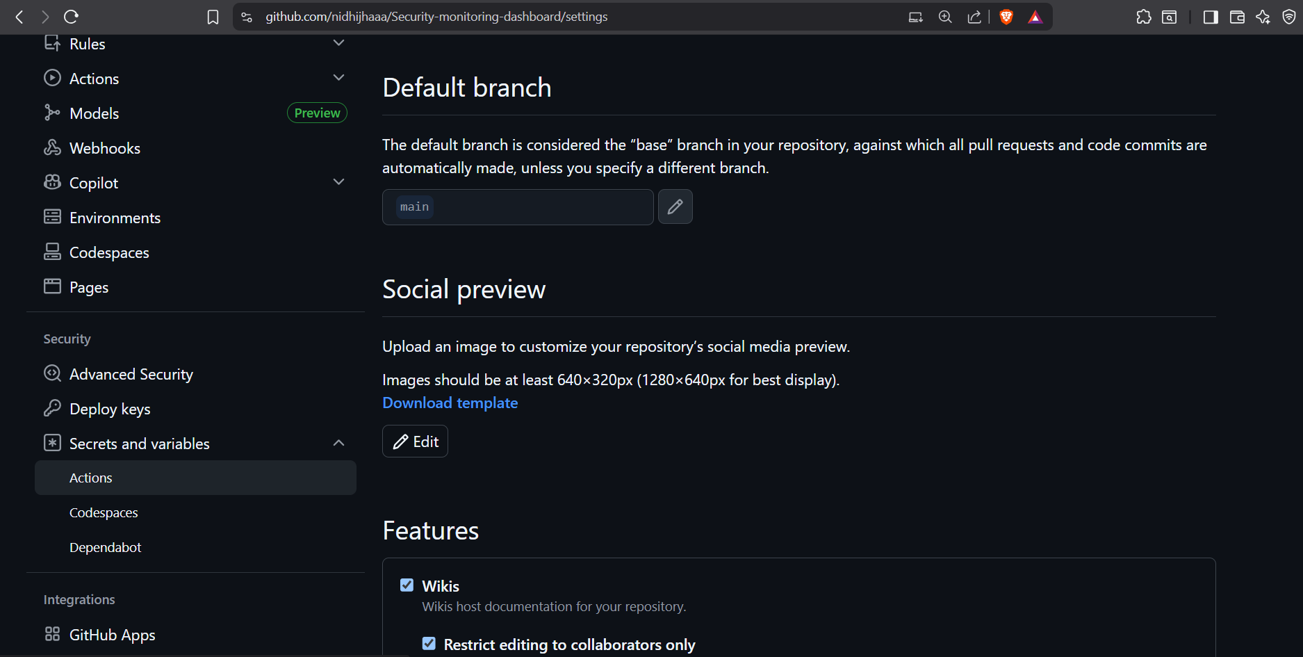

- Click New repository secret.

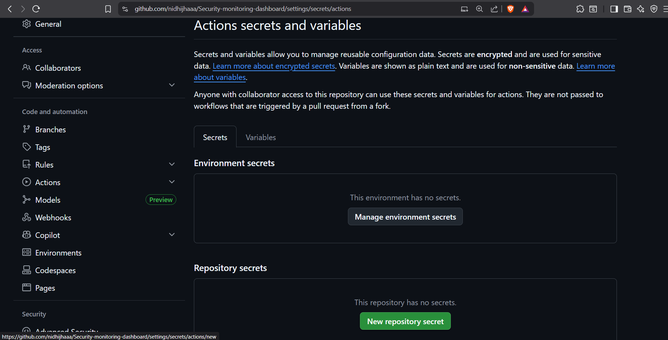

- Name: GH_DASHBOARD_TOKEN
- Value: Paste the Personal Access Token you just generated.
- Click Add secret.

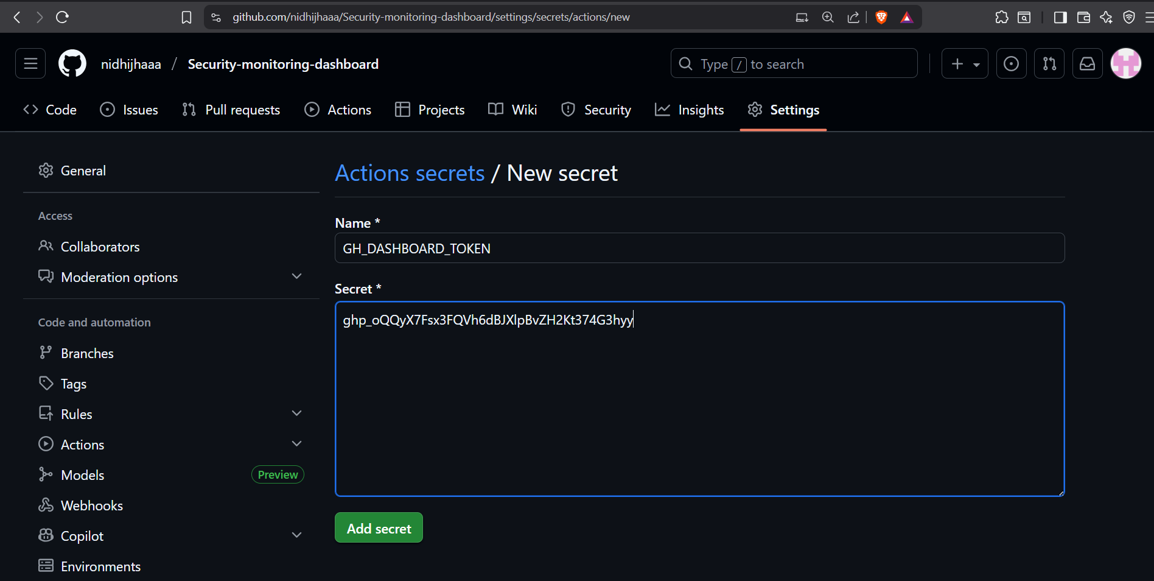

Step 3: Create the Dashboard Script

- Click on Add file Create new file

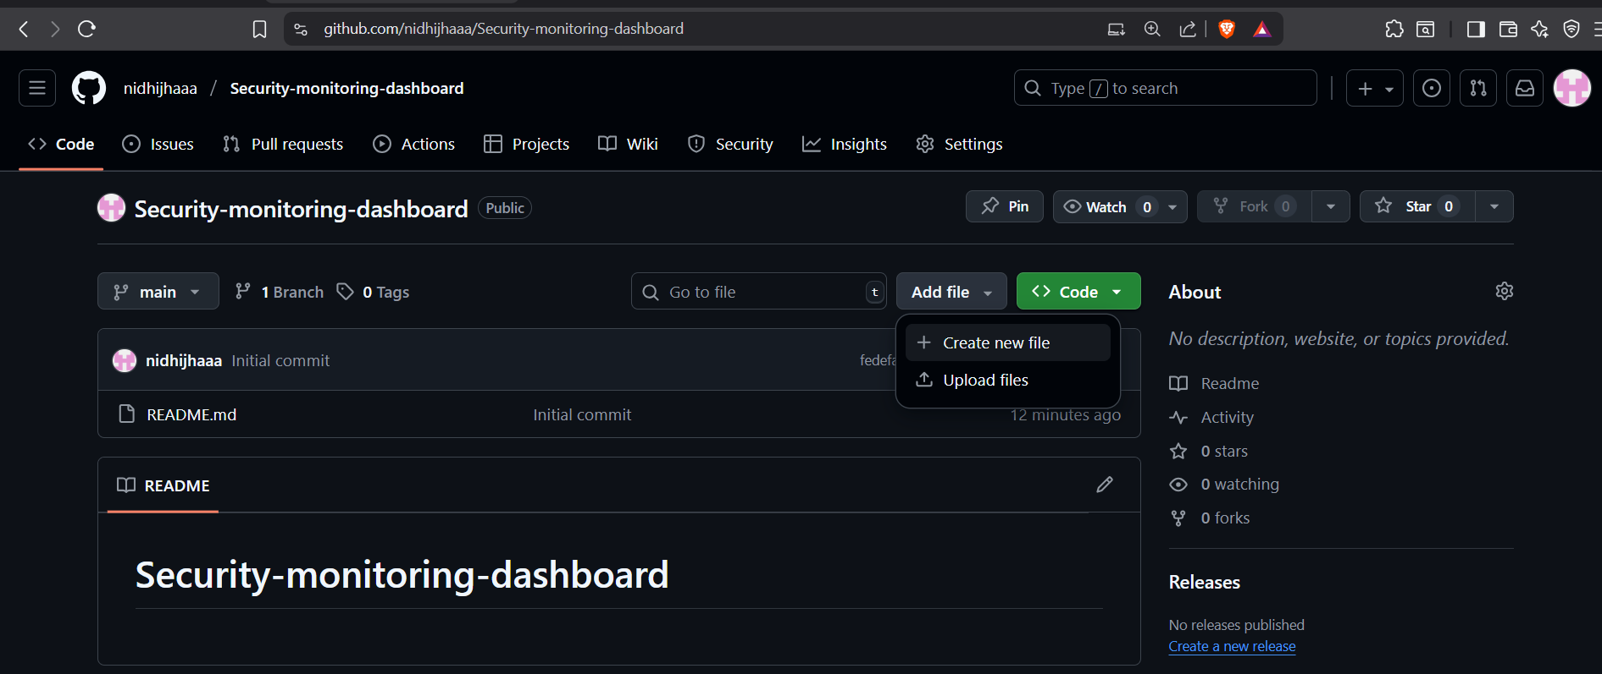

- Create a new directory named scripts/.
- Inside the scripts/ directory, create a new file named generate_dashboard.py

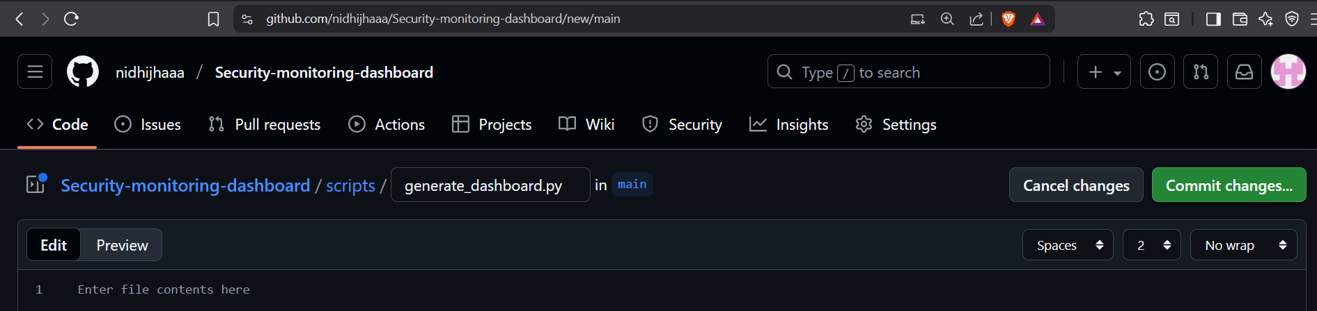

- Copy and paste the following Python code into the file:

# scripts/generate_dashboard.py
import requests
import os
import json
from datetime import datetime

# Configuration - Get variables from environment
GH_TOKEN = os.getenv('GH_TOKEN')
REPO = os.getenv('GH_REPOSITORY') # e.g., 'nidhijhaaa/Security-monitoring-dashboard'
OUTPUT_FILE = 'index.html' # Changed to index.html for GitHub Pages

# Headers for GitHub API authentication
headers = {
'Authorization': f'token {GH_TOKEN}',
'Accept': 'application/vnd.github.v3+json'
}

def fetch_github_alerts():
"""Fetches Dependabot and CodeQL alerts from the GitHub API"""
alerts_url = f'https://api.github.com/repos/{REPO}/code-scanning/alerts'
dependabot_url = f'https://api.github.com/repos/{REPO}/dependabot/alerts'

all_alerts = []

# Fetch Code Scanning (CodeQL) alerts
print("Fetching CodeQL alerts...")
try:
response = requests.get(alerts_url, headers=headers)
if response.status_code == 200:
codeql_alerts = response.json()
for alert in codeql_alerts:
# Only count 'open' or 'fixed' alerts, ignore 'dismissed'
if alert.get('state') in ['open', 'fixed']:
all_alerts.append({
'type': 'CodeQL',
'created_at': alert['created_at'],
'state': alert['state'],
'rule': alert['rule']['id'],
'severity': alert['rule']['severity'].lower(),
'html_url': alert['html_url']
})
print(f"Found {len(codeql_alerts)} CodeQL alerts")
else:
print(f"Error fetching CodeQL alerts: {response.status_code} - {response.text}")
except Exception as e:
print(f"Exception fetching CodeQL alerts: {str(e)}")

# Fetch Dependabot alerts
print("Fetching Dependabot alerts...")
try:
response = requests.get(dependabot_url, headers=headers)
if response.status_code == 200:
dependabot_alerts = response.json()
for alert in dependabot_alerts:
# Only process 'open' alerts
if alert.get('state') == 'open':
all_alerts.append({
'type': 'Dependabot',
'created_at': alert['created_at'],
'state': alert['state'],
'rule': alert['security_advisory']['summary'],
'severity': alert['security_vulnerability']['severity'].lower(),
'html_url': alert['html_url']
})
print(f"Found {len(dependabot_alerts)} Dependabot alerts")
else:
print(f"Error fetching Dependabot alerts: {response.status_code} - {response.text}")
except Exception as e:
print(f"Exception fetching Dependabot alerts: {str(e)}")

print(f"Total alerts found: {len(all_alerts)}")
return all_alerts

def generate_html_dashboard(alerts):
"""Generates the HTML dashboard from the alerts data"""
print("Generating HTML dashboard...")

# Count alerts by type and severity
severity_count = {'critical': 0, 'high': 0, 'medium': 0, 'low': 0, 'warning': 0, 'note': 0, 'error': 0}
for alert in alerts:
sev = alert['severity']
severity_count[sev] = severity_count.get(sev, 0) + 1

total_alerts = len(alerts)
current_time = datetime.now().strftime("%Y-%m-%d %H:%M:%S")

# HTML Template
html_content = f"""
<!DOCTYPE html>
<html lang="en">
<head>
<meta charset="UTF-8">
<meta name="viewport" content="width=device-width, initial-scale=1.0">
<title>Security Dashboard - {REPO}</title>
<script src="https://cdn.jsdelivr.net/npm/chart.js"></script>
<style>
body {{
font-family: Arial, sans-serif;
margin: 40px;
line-height: 1.6;
color: #333;
}}
.container {{
max-width: 1200px;
margin: 0 auto;
}}
.header {{
background: #f5f5f5;
padding: 20px;
border-radius: 8px;
margin-bottom: 20px;
}}
.card {{
border: 1px solid #ddd;
border-radius: 8px;
padding: 20px;
margin: 10px 0;
box-shadow: 0 2px 4px rgba(0,0,0,0.1);
}}
.severity-critical {{ color: #ff2c2c; font-weight: bold; }}
.severity-high {{ color: #ff6e6e; }}
.severity-medium {{ color: #ffbf00; }}
.severity-low {{ color: #6ecbff; }}
.alert-list {{
list-style-type: none;
padding: 0;
}}
.alert-list li {{
padding: 8px;
border-bottom: 1px solid #eee;
}}
.alert-list li:last-child {{
border-bottom: none;
}}
.chart-container {{
height: 300px;
margin: 20px 0;
}}
</style>
</head>
<body>
<div class="container">
<div class="header">
<h1>Security Dashboard</h1>
<p>Repository: <strong>{REPO}</strong></p>
<p>Last updated: <strong>{current_time}</strong></p>
<p>Total Alerts: <strong>{total_alerts}</strong></p>
</div>

<div class="card">
<h2>Security Summary</h2>
<div class="chart-container">
<canvas id="severityChart"></canvas>
</div>
</div>

<div class="card">
<h2>Recent Alerts (Top 10)</h2>
<ul class="alert-list">
"""

# Add the 10 most recent alerts to the list
sorted_alerts = sorted(alerts, key=lambda x: x['created_at'], reverse=True)[:10]
if sorted_alerts:
for alert in sorted_alerts:
html_content += f"""
<li>
<span class="severity-{alert['severity']}">[{alert['severity'].upper()}]</span>
<strong>{alert['type']}</strong>: {alert['rule']}
<br>
<small>Created: {alert['created_at'].replace('T', ' ').replace('Z', '')}</small>
<a href="{alert['html_url']}" target="_blank" style="float: right;">View Details</a>
</li>
"""
else:
html_content += "<li>No security alerts found. Good job! </li>"

html_content += """
</ul>
</div>
</div>

<script>
const ctx = document.getElementById('severityChart').getContext('2d');
const severityChart = new Chart(ctx, {
type: 'bar',
data: {
labels: ['Critical', 'High', 'Medium', 'Low', 'Warning', 'Note', 'Error'],
datasets: [{
label: '# of Alerts by Severity',
data: [
""" + str(severity_count['critical']) + """,
""" + str(severity_count['high']) + """,
""" + str(severity_count['medium']) + """,
""" + str(severity_count['low']) + """,
""" + str(severity_count['warning']) + """,
""" + str(severity_count['note']) + """,
""" + str(severity_count['error']) + """
],
backgroundColor: [
'#ff2c2c', '#ff6e6e', '#ffbf00', '#6ecbff', '#aaaaaa', '#dddddd', '#ff2c2c'
],
borderWidth: 1
}]
},
options: {
responsive: true,
maintainAspectRatio: false,
scales: {
y: {
beginAtZero: true,
title: {
display: true,
text: 'Number of Alerts'
}
},
x: {
title: {
display: true,
text: 'Severity Level'
}
}
},
plugins: {
title: {
display: true,
text: 'Security Alerts by Severity'
}
}
}
});
</script>
</body>
</html>
"""

# Write the HTML to a file
with open(OUTPUT_FILE, 'w', encoding='utf-8') as f:
f.write(html_content)
print(f"Dashboard generated: {OUTPUT_FILE}")

if __name__ == '__main__':
print("Starting dashboard generation...")
print(f"Repository: {REPO}")
alerts_data = fetch_github_alerts()
generate_html_dashboard(alerts_data)
print("Dashboard generation completed!")

(You can change the styling , content according to your need).

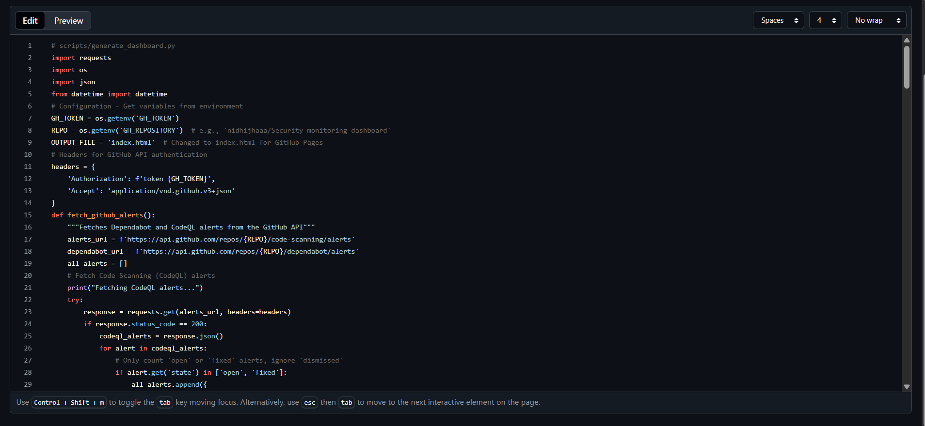
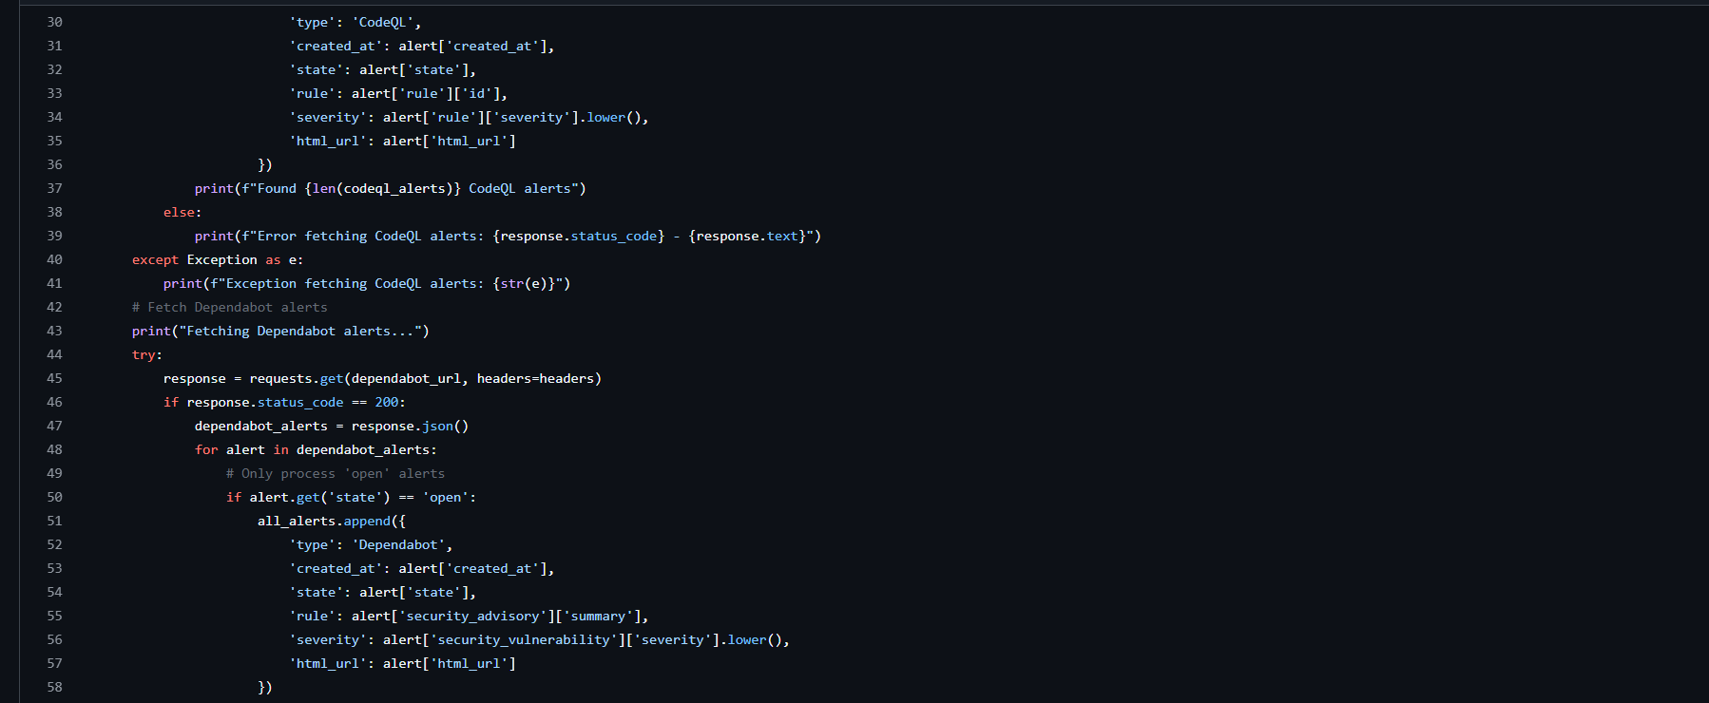
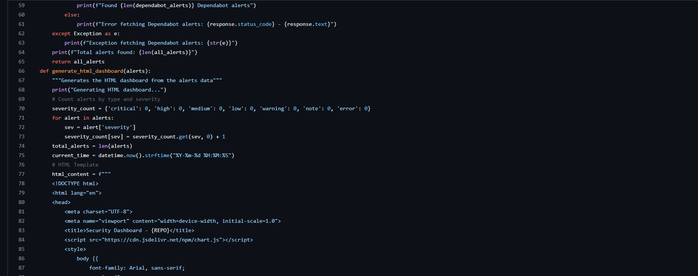
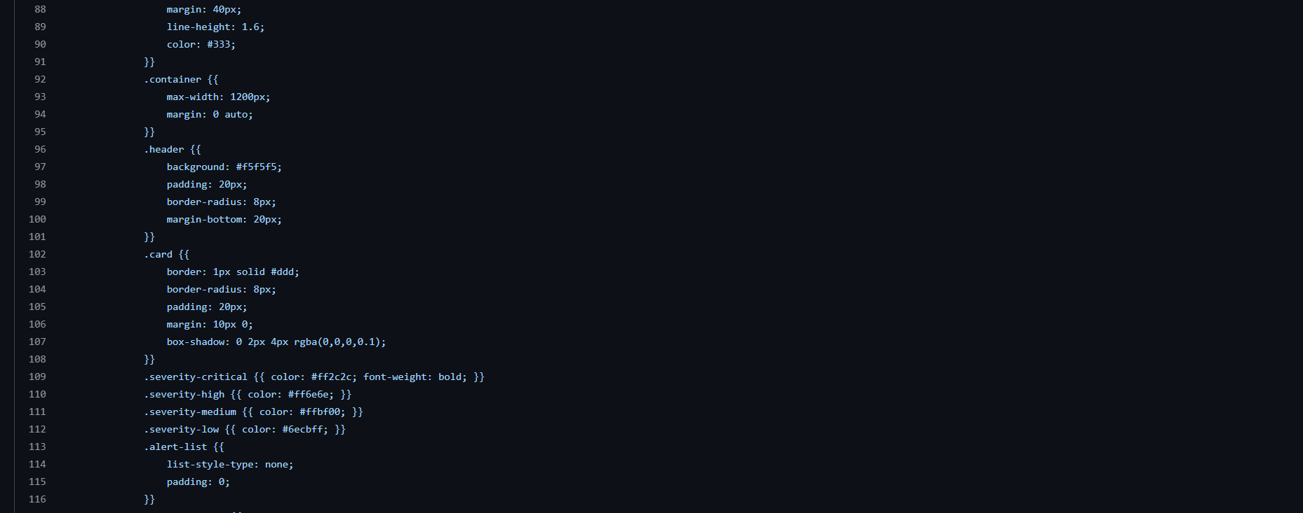
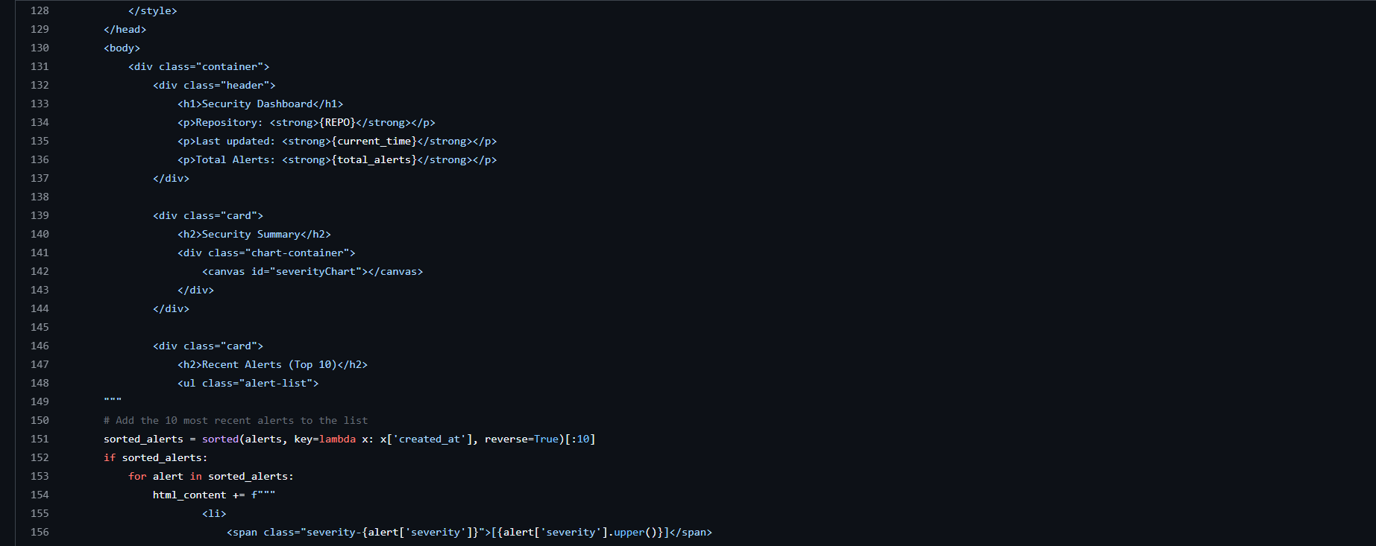
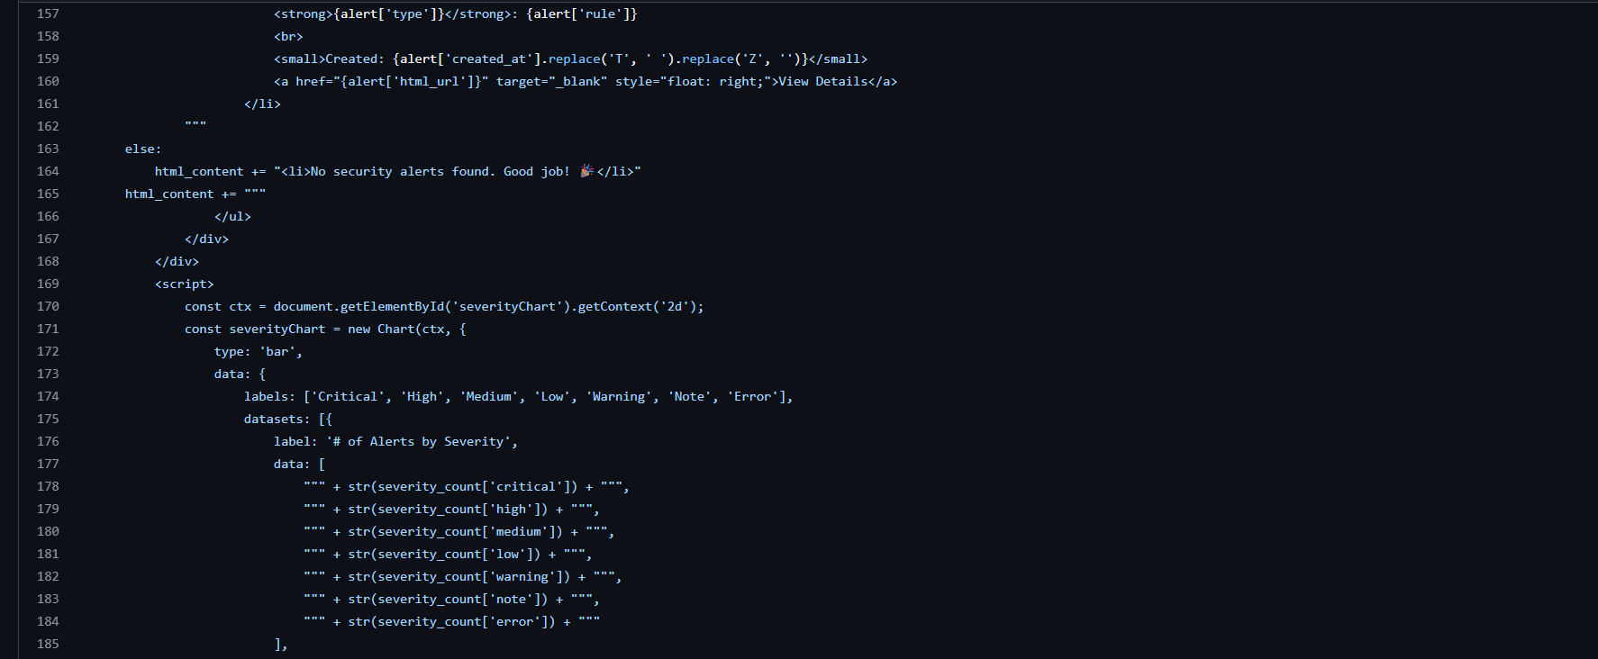
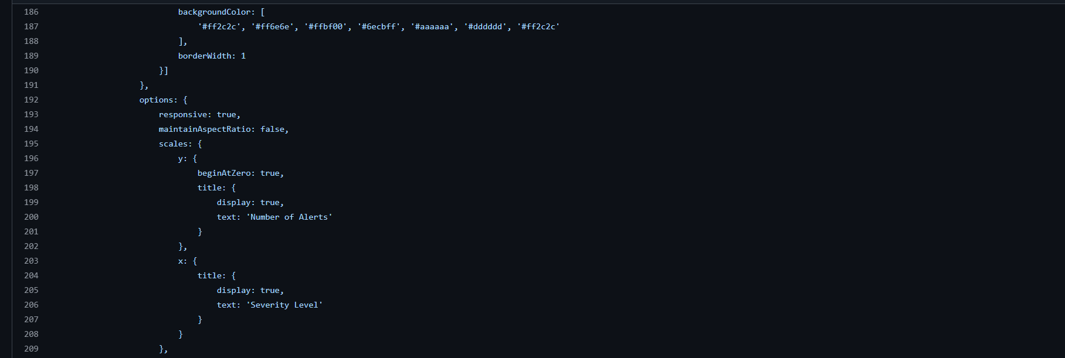
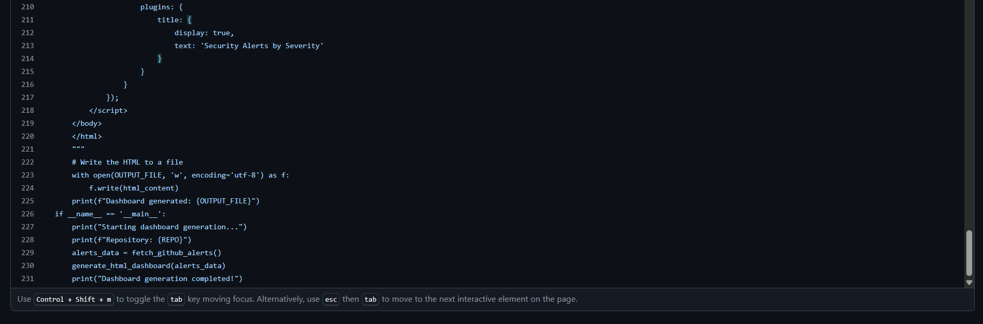

- Click on “Commit changes”.
- Add commit message.
- Select “Commit directly to the main branch”
- Click “Commit changes”.
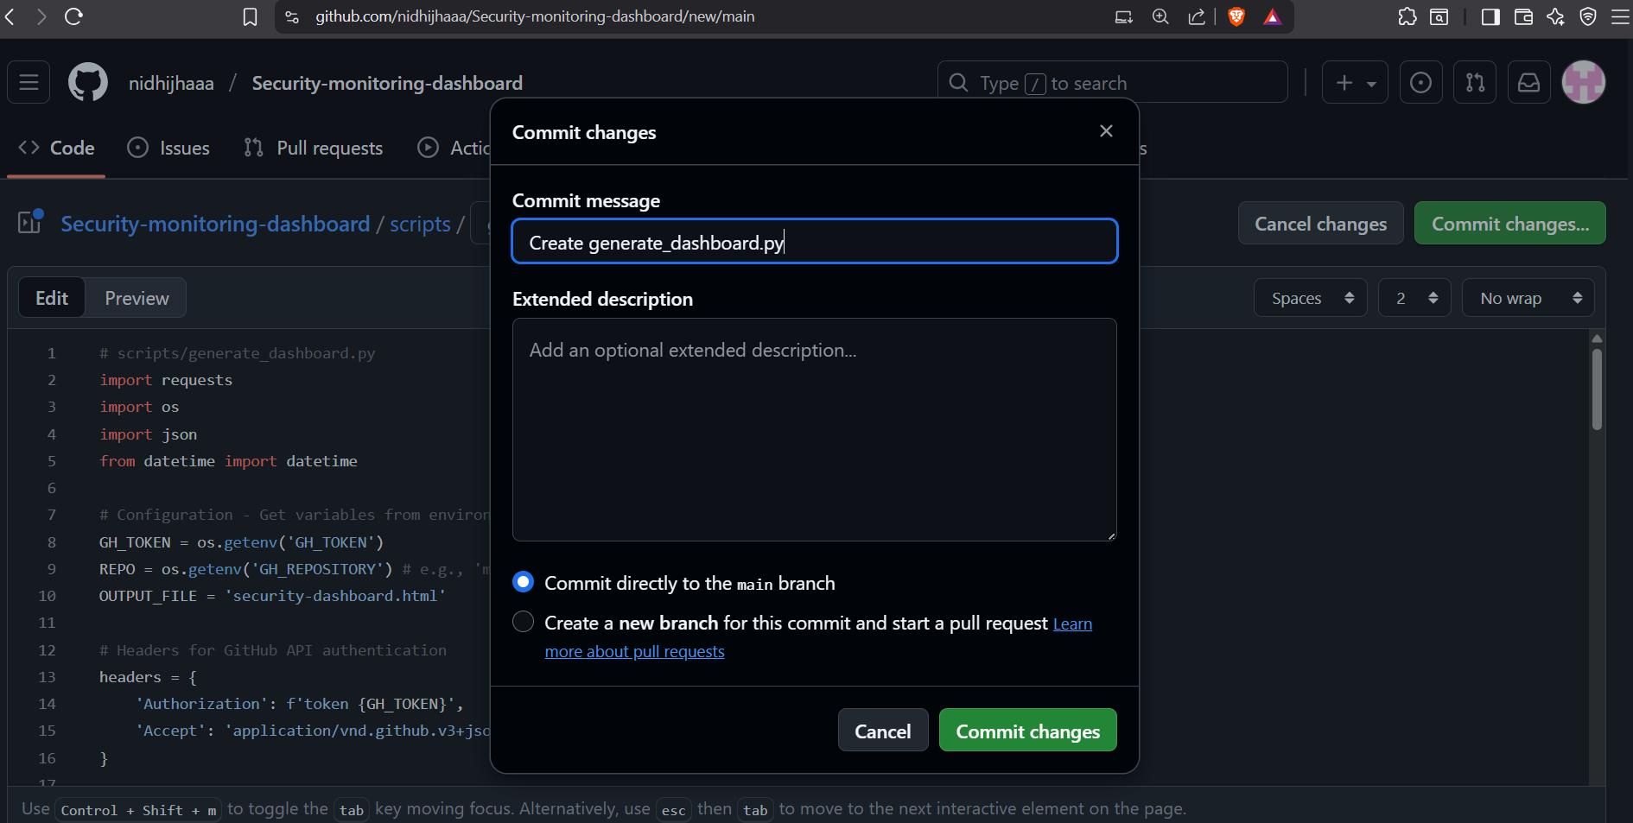

Step 4: Create the Automation Workflow

- Create a new workflow file in .github/workflows/ named dashboard.yml

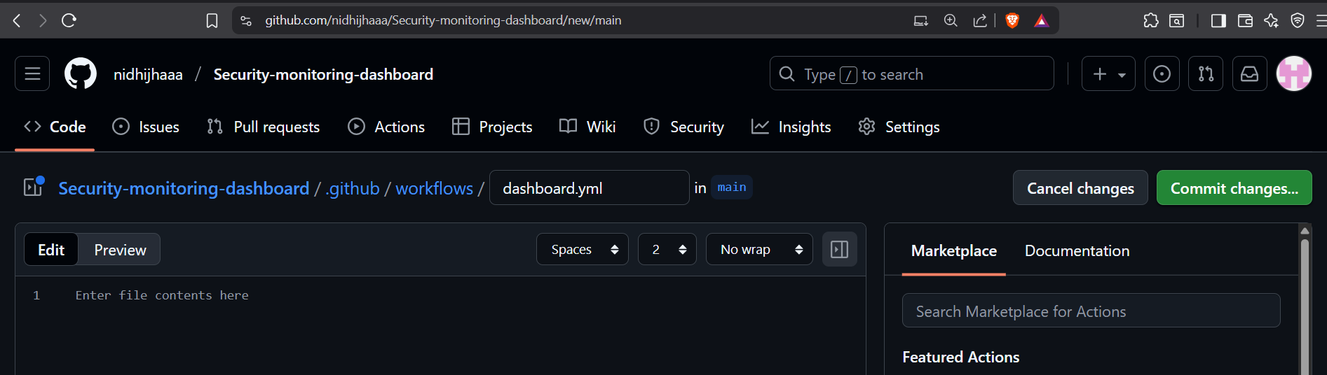

- Copy and paste the following YAML code:

name: Generate Security Dashboard

on:
workflow_dispatch: # Allows manual triggering
schedule:
- cron: '0 8 * * 1' # Run every Monday at 8:00 AM UTC
push:
branches: [ "main" ]
paths: # Only run if the script or workflow changes
- '.github/workflows/dashboard.yml'
- 'scripts/generate_dashboard.py'

jobs:
generate-dashboard:
runs-on: ubuntu-latest
permissions:
contents: write
pages: write
id-token: write
steps:
- name: Checkout code
uses: actions/checkout@v4

- name: Set up Python
uses: actions/setup-python@v4
with:
python-version: '3.10'

- name: Install dependencies
run: pip install requests

- name: Generate Dashboard
env:
GH_TOKEN: ${{ secrets.GH_DASHBOARD_TOKEN }}
GH_REPOSITORY: ${{ github.repository }}
run: python scripts/generate_dashboard.py

- name: Debug - Check generated files
run: |
echo "Current directory:"
pwd
echo "Files in directory:"
ls -la
echo "Checking if index.html exists:"
if [ -f "index.html" ]; then
echo "index.html exists!"
echo "First few lines:"
head -3 index.html
else
echo "index.html does NOT exist!"
exit 1
fi

- name: Deploy to GitHub Pages
uses: peaceiris/actions-gh-pages@v3
with:
github_token: ${{ secrets.GITHUB_TOKEN }}
publish_dir: ./
publish_branch: gh-pages
keep_files: true
force_orphan: true # This ensures a clean deployment every time
user_name: 'github-actions[bot]'
user_email: 'github-actions[bot]@users.noreply.github.com'

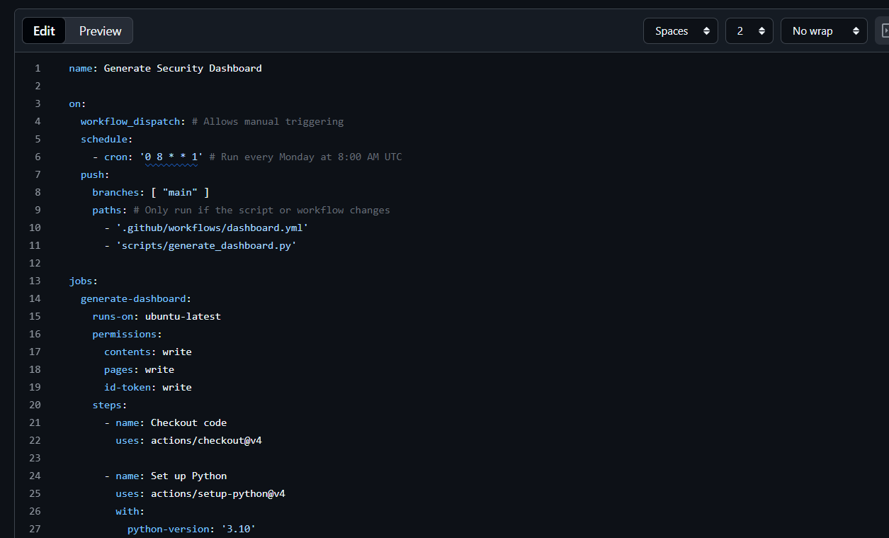

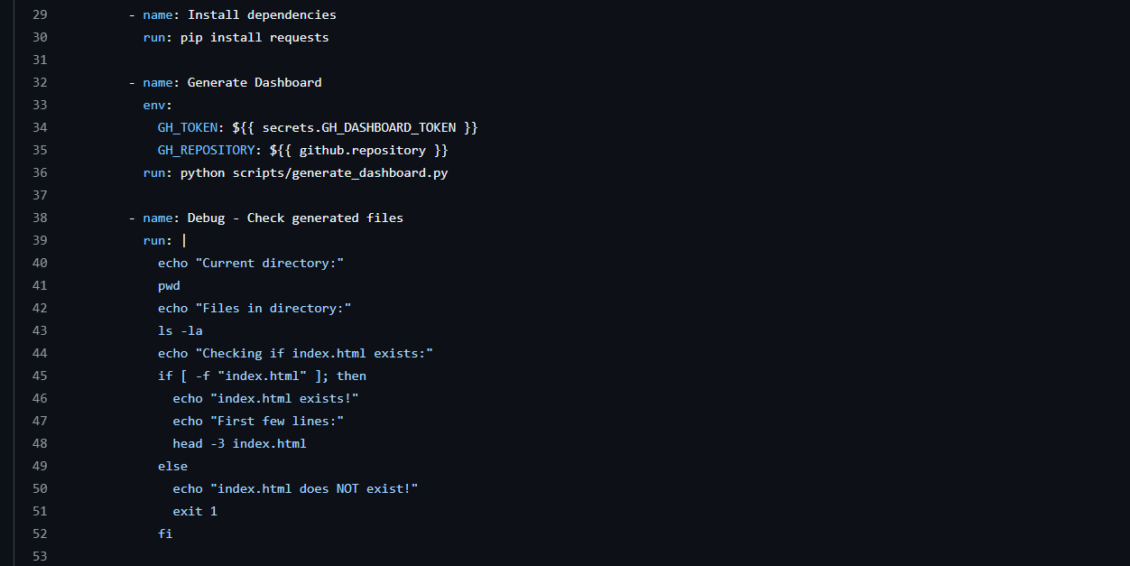
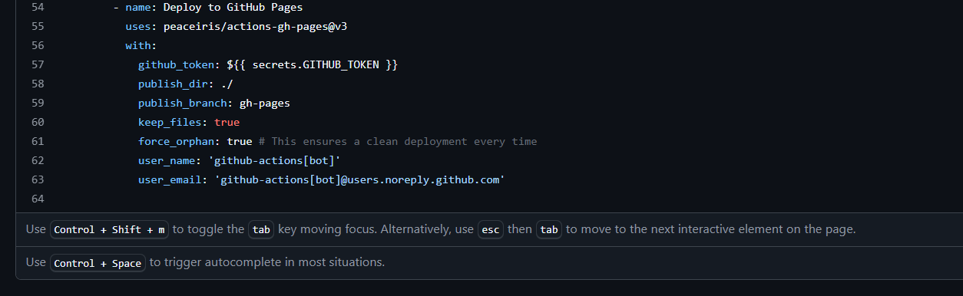

- Commit this file.

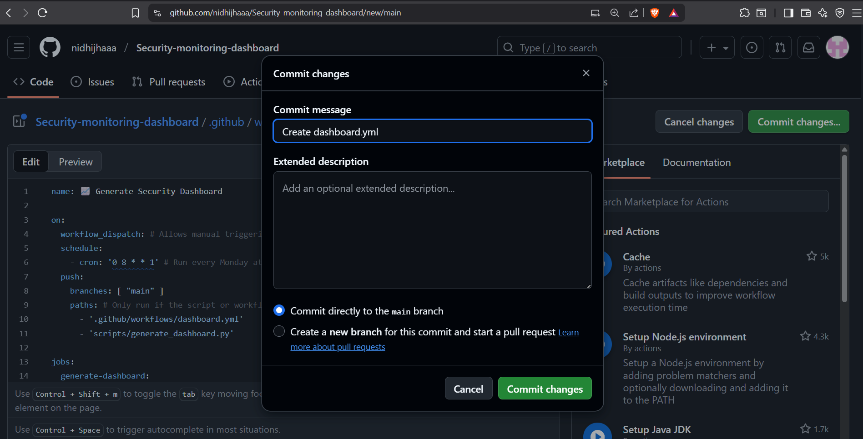

Step 5: Enable GitHub Pages

To host the generated dashboard for free on GitHub.
- Go to your repository Settings Pages.

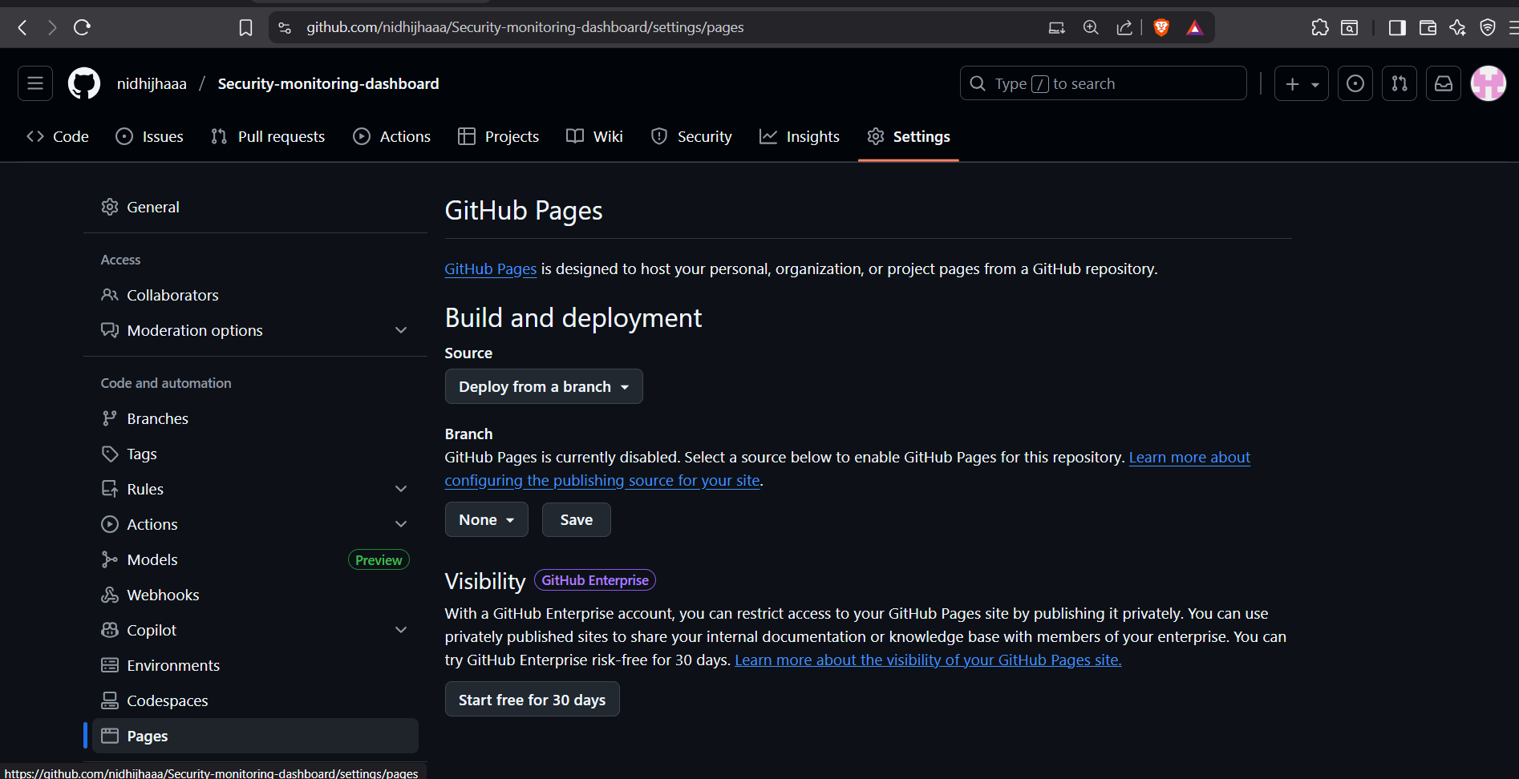

- Under Build and deployment, set Source to Deploy from a branch.
- Set the branch to gh-pages and folder to /(root).
- Click Save.

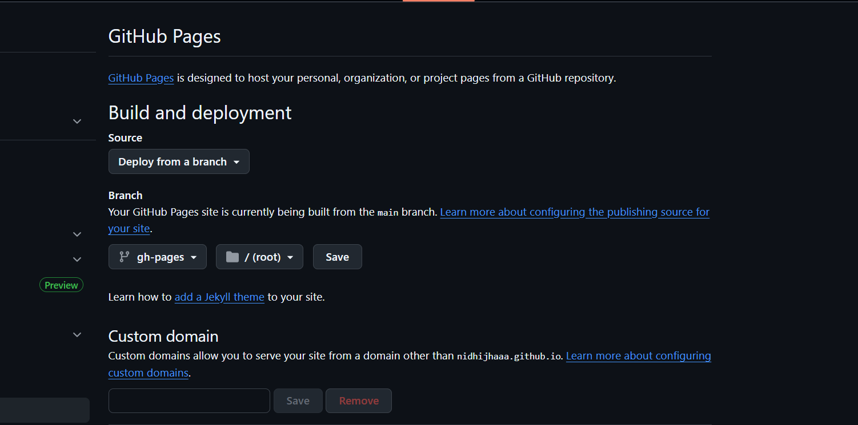

Step 6: Run the Workflow and View the Dashboard

- Go to the Actions tab in your repository.
- Pages build and deployment workflow is running. Wait for few mins.

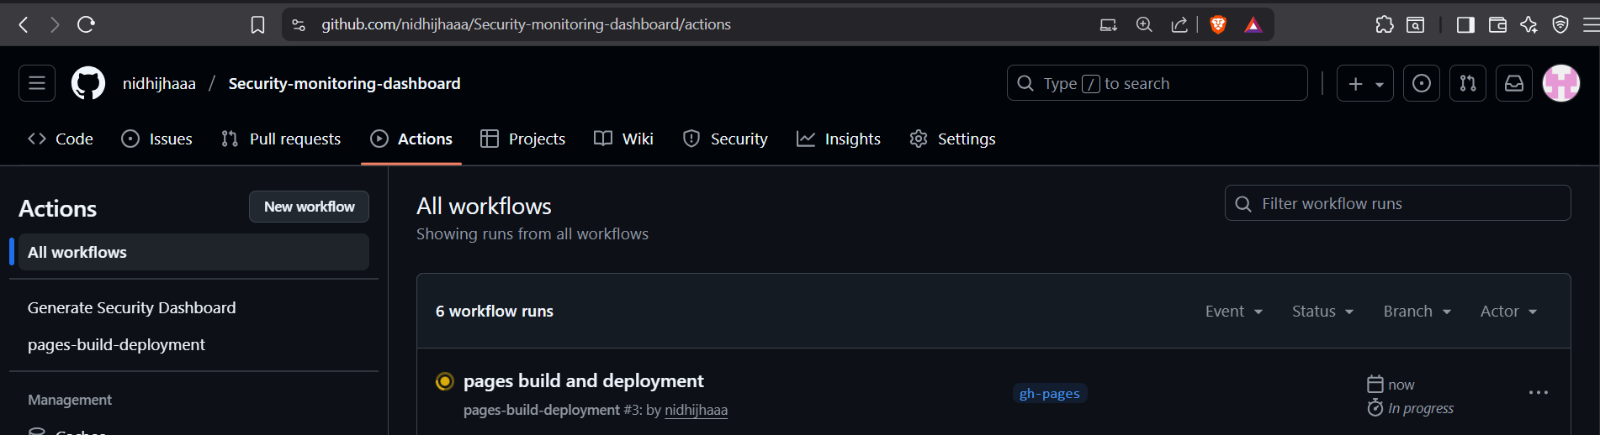

- Deployed successfully.
- You can see the URL.
- Click the link to see your live, auto-updating security dashboard

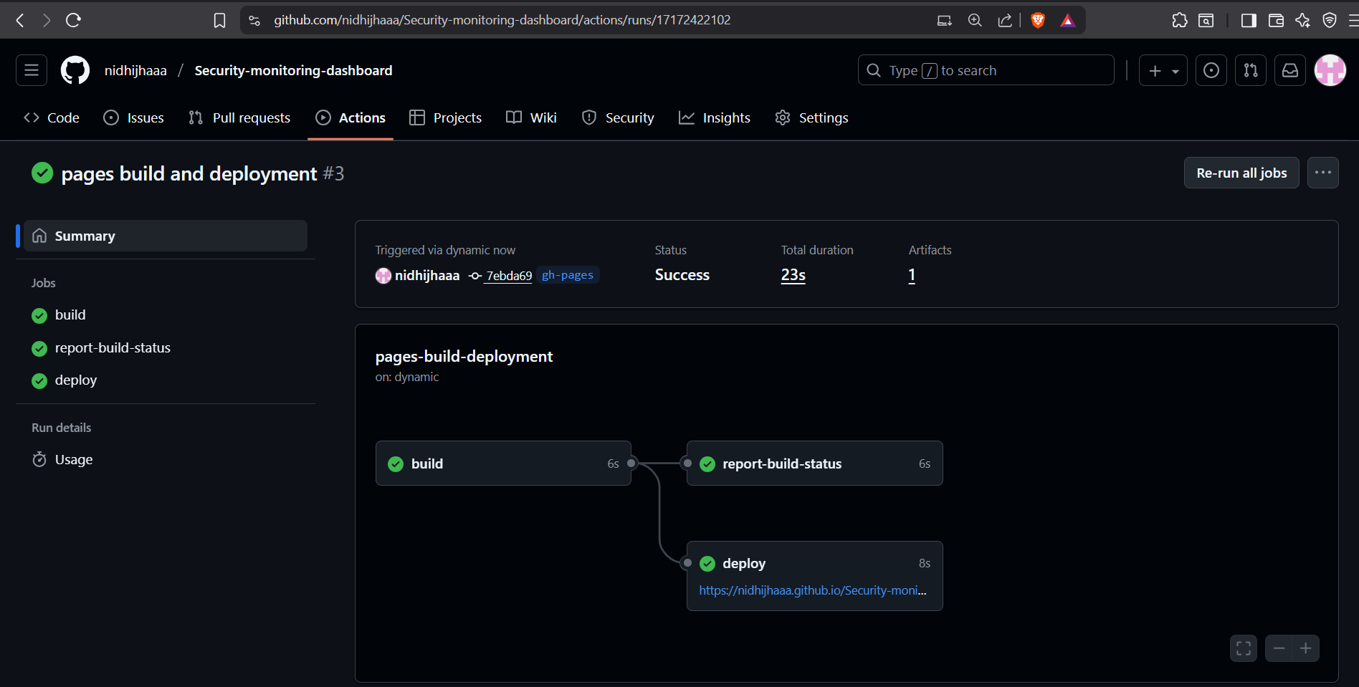

- Security dashboard is created successfully.

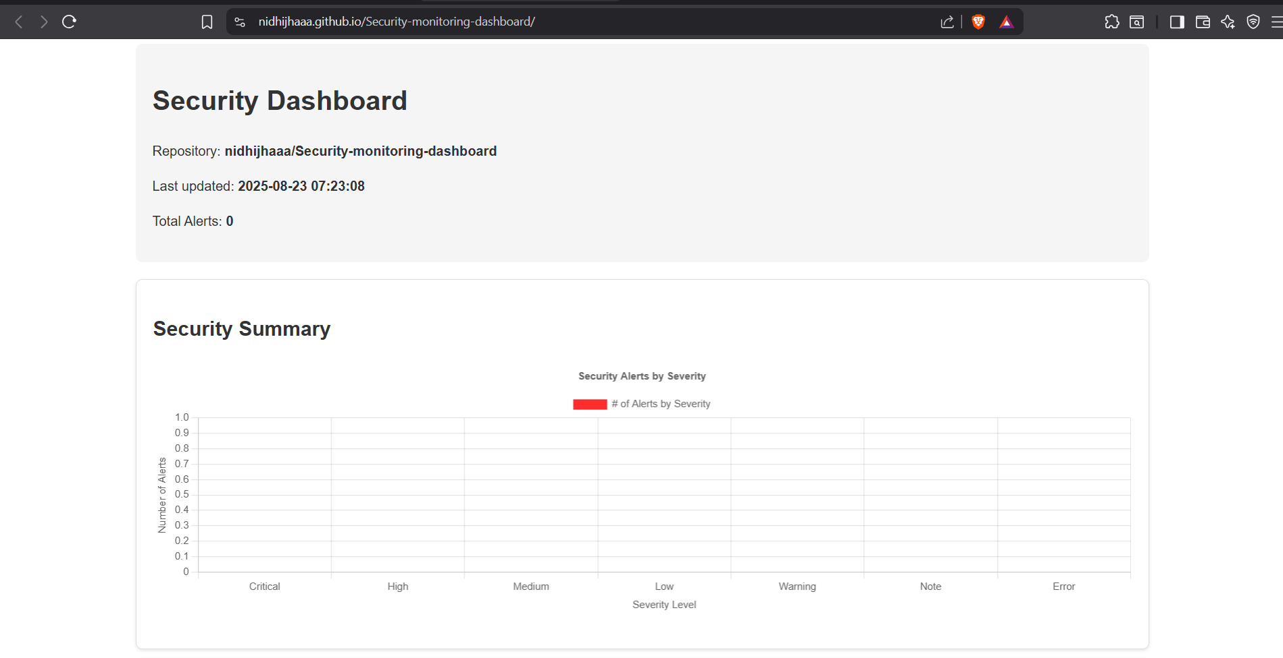

Conclusion

By implementing the Security Monitoring Dashboard, we establish a centralized, automated, and transparent mechanism for tracking the security posture of our repositories. This solution leverages GitHub’s native security features, combined with custom automation, to provide real-time visibility, trend analysis, and actionable insights.

The dashboard not only enhances operational efficiency by reducing manual effort but also strengthens governance and compliance through consistent reporting and audit-ready data. Hosting the dashboard on GitHub Pages ensures accessibility with minimal infrastructure overhead, making the approach both scalable and cost-effective.

Overall, this solution empowers teams to move from a reactive security approach to a proactive, data-driven strategy, enabling faster remediation, informed decision-making, and long-term improvement of security practices across projects.

